White paper

**Singh, Mahendra Pratap**

Computer science corporation | TECHINICAL WHITE PAPAER

**White paper**

**Aug, 2016**

**RMA Performance Test Benchmark**

**Project: RMA Performance System Test (PST) Tool: HP’s Performance Center**

**RMA Performance Test Benchmark**

**Project: Risk Master Performance System Test (PST)**

**Tool: HP’s Performance Center**

**ABSTRACT**

**In June 2016:**

* Computer Science Corporation Performance LAB (PLAB) conducted Performance System Test (PST) on-
* **Application:**

Risk Master Application Property & Casualty

(P&C) Claim Management Software (Now on

referred to as RMA)

* **Tool:**

HP’s Performance Center

* **Operating System:**

Windows Server 2008 R2 Enterprise

**The Benchmark Performance Test was Successful in:**

* Demonstrating a near-linear scalability to 100 concurrent users
* Running against a database of above 600,000 claims while maintaining steady performance*.*

**Contents**

INTRODUCTION 3

CSC- RISK MASTER ACCELARATOR 4

CSC – Risk Master Accelerator 4

RISKMASTER Accelerator Supports All Industries 4

CSC –PERFORMANCE TEST LAB 4

PLAB-RMA TEAM UP 5

HP PERFORMANCE CENTER 5

HP’s Performance Center 5

PERFORMANCE CENTER WORKFLOW 6

PERFORMANCE CENTER BENEFITS 6

BENCHMARK TESTING OVERVIEW 7

The Benchmarking Tests Aimed 7

A Variety of Tests Were Performed 7

PLAB TEST ENVIRONMENT 9

Database Servers 9

Application Servers 9

BENCHMARK TESTING SERVERS 11

TEST SCENARIOS 11

BENCH MARK TESTING RESULTS 14

SUMMARY 17

ADDITIONAL INFORMATION 18

# **INTRODUCTION**

Flattening of global market provides a world of opportunities and challenges for insurers. Companies need **flexible and dependable technology that helps them to respond quickly to changing requirements/conditions and thus meet the local needs of diverse markets**.

**RMA Claims Management software** suite helps insurance carriers meet these challenges with a comprehensive solution that is ideally suited in many scenarios, such as:

* Comprehensive, integrated claims and risk management solution
* Scalable [RMIS](http://www.csc.com/risk_management_and_claims/offerings/72458/78246-rmis_solutions) analysis and reporting capabilities
* Automate policy administration
* Supports all industries including transportation, manufacturing, healthcare and so on

**Following White Paper Covers:**

* Introduction to RMA Claim Administration software
* Overview of HP’s Performance Center- a proven performance testing tool for various web applications.
* Advantages of Performance Center including manageability, scalability and reliability are highlighted.
* Benchmark test results that PC scales to meet the needs of even the largest Virtual User set of RMA Claim Administration Software are demonstrated.

***Enterprise customers can be confident in the choice of RMA Claim Administration Software and its performance benchmarks***.

# **CSC- RISK MASTER ACCELARATOR**

## **CSC – Risk Master Accelerator**

* **World’s widely used risk and claims management software**
* Provides a variety of powerful, scalable [RMIS](http://www.csc.com/risk_management_and_claims/offerings/72458/78246-rmis_solutions) analysis and reporting capabilities available independently or as part of a comprehensive, integrated claims and risk management solution.
* **Has the capability to evaluate injuries, control legal costs, identify potential fraud, automate policy administration and so on.**

## **RISKMASTER Accelerator Supports All Industries**

* Including transportation, manufacturing, healthcare, retail, energy, telecommunications, education, government entities and third-party administrators.

For more information about RMA, visit [***www.csc.com***](http://www.csc.com/)

# **CSC –PERFORMANCE TEST LAB**

***Performance Test Lab - PLAB*** is a team of experienced resources equipped with market leading tools & technology to test the performance of CSC’s IP products such ***as Exceeds, POINT, Agency Links, RMA and so on.***

**PLAB-RMA TEAM UP**

**PLAB & RMA Team up for performance test of RMA 16.1 GA release product -**

* **Performance Testing for RMA product occurs in two phases, Initial & Final Performance System Test (P.S.T.) phase.** Both the phases are performed by the PLAB resources.
* The first set of performance tests are carried out during the initial phase of project. PLAB Team records, variablize & execute all test case scripts using ***HP’s Performance Center v12.00.***
* **After each round PLAB team shares the execution results & analysis summary sheet to RMA dev team for analysis.** Inputs from the analysis of initial round PST is considered in Final Round PST by PLAB team.

# **HP PERFORMANCE CENTER**

## **HP’s Performance Center**

* **Suite of integrated performance testing solutions** that can emulate thousands of concurrent users to apply production workloads to virtually any environment.
* **Identifies potential performance bottlenecks and help diagnose & fix the root cause of the problems.**

# **PERFORMANCE CENTER WORKFLOW**

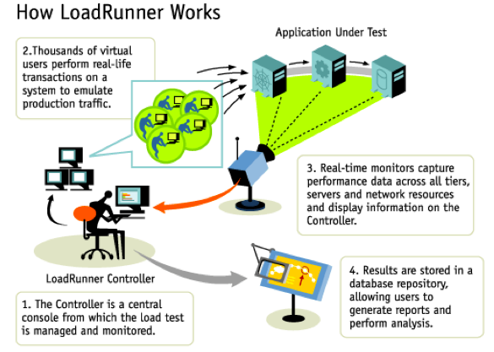

# **PERFORMANCE CENTER BENEFITS**

* Centralized Test Environment
* Web Interface
* Leverages Capabilities of Load Runner

**BENCHMARK TESTING OVERVIEW**

**RMA & PLAB Team carried out real-world benchmarking tests with performance servers deployed at Blythewood, South Carolina to evaluate and optimize the performance and scalability of CSC’s RMA Suite running on HP’s Performance Center**.

## **The Benchmarking Tests Aimed**

* To simulate the typical daily activities of agents at a large insurer, with up to 100 concurrent users running against a database of over 600,000 claims. Other records used were in multiple of claims.

|  |  |  |
| --- | --- | --- |
| **Database characteristics used for Performance test:** | | |
| **Claim** | 600,000 | Spread by Line of business (GC & WC) |
| **Events** | 600,000 | 1 Per Claim |
| **Reserves current** | 1200,000 | 2 Per claim |
| **Reserves History** | 2400,000 | 4 Per Claim |
| **Payments** | 4200,000 | 7 Per Claim |
| **Entities** | 4200,000 | 7 Per Claim |
| **Diaries** | 9000,000 | 15 Per Claim |
| **Enhanced Notes** | 7200,000 | 12 Per Claim |

* This was achieved on one application server and one database server.

## **A Variety of Tests Were Performed**

* **Single Application Server- Mixed User Test (Load Test):**

Investigated the performance of RMA on a single application server with various numbers of virtual users i.e. 1, 5, 10, 20, 50 & 100 VUs.

* **Single Application Server**-**Time bound Mixed Test*:*** A Mixed test gets constructed and executed. The Mixed test comprises of selected Test Case scripts. The duration of the execution of test case is 60 minutes. The RMA dev team will finally determine that how long the mixed test will be executed as well as the final throughput targets to be achieved.

In Mixed Test, only frequently used scenarios which a real world user would perform, are captured & performance tested. See the difference Table 1 & 3.

* Following table describes the transaction throughput that is set to execute during the RMA mixed test. For a mixed test to be considered a candidate for a valid run, the transaction throughput must meet the listed Target Number of Transactions Processed.

|  |  |
| --- | --- |
| **Scripts** | **Target Number of Transactions Processed** |
| ***Test Case 1***  Create GC Claim🡪Download Policy from PIJ🡪 Add insured as Claimant🡪 Create Recovery reserve🡪Make a Collection. | 3 |
| ***Test Case 2***  Search an existing GC Claim🡪Download Policy from PIJ🡪Add a Claimant manually, not as Insured from Policy | 3 |
| ***Test Case 3***  Search and View Employee Information | 3 |
| ***Test Case 4***  Display Organization Hierarchy Tree | 2 |
| ***Test Case 5***  Create Event 🡪Display Recent Events | 2 |
| ***Test Case 6***  Display Diary list 🡪 Create a Diary | 2 |
| ***Test Case 7***  Display Executive | 3 |
| ***Test Case 8***  Create Enhanced Note | 4 |
| ***Test Case 9***  Create Entity | 4 |
| ***Test Case 10***  Maintain Entity Information | 2 |
| **Total Transaction Counts:** | **28** |

**Table 1: RMA Mixed Test set (Time bound)**

# **PLAB TEST ENVIRONMENT**

***The test infrastructure included below major components:***

* Database Server
* Application Server
* Policy Server
* Workstation as Clients

## **Database Servers**

* Dual Xeon 2.53 GHz Quad Core server will be used for Microsoft SQL 2008 R2 64-bit Server.

Following description provides the servers details:

* IBM eServer Blade Center (Model 8677)
* The blade is an HS22 blade with dual XEON 2.53 GHz Quad Core processors, 32 GB RAM, and dual 300 GB Mirrored SCSI drives (RAID 0)
* It is connected to a Cisco switch via a 1 GBps adapter.

## **Application Servers**

* Dual Xeon 2.53 GHz Quad Core Processor application server for both Application/Web servers with TURBO Boost option enabled.
* Following description provides the details of these servers:
* IBM eServer Blade Center (Model 7870)
* Blade is an HS22 blade with dual XEON 2.53 GHz Quad processors, 32 GB RAM, dual 300GB 10K Mirrored SCSI drives (RAID 0)
* It is connected to a Cisco switch via 1 GBPS adapter.

***This ensured that the tests were carried out at full throttle, and they provided an accurate measurement of the scalability of the system.***

**Database Servers**

* Dual Xeon 2.53 GHz Quad Core server will be used for Microsoft SQL 2008 R2 64-bit Server.
* Following description provides the servers details:
  + - * IBM eServer Blade Center (Model 8677).
      * The blade is an HS22 blade with dual XEON 2.53 GHz Quad Core processors, 32 GB RAM, and dual 300 GB Mirrored SCSI drives (RAID 0).
      * It is connected to a Cisco switch via a 1 GB/ps adapter.

**WorkStation as Clients**

* **IBM Net Vista**:

Pentium IV 2.8 GHz processor with 1GB RAM

* **Lenovo Think Centre**

Duo Core 3.0 GHz processor with 2GB RAM

# **BENCHMARK TESTING SERVERS**

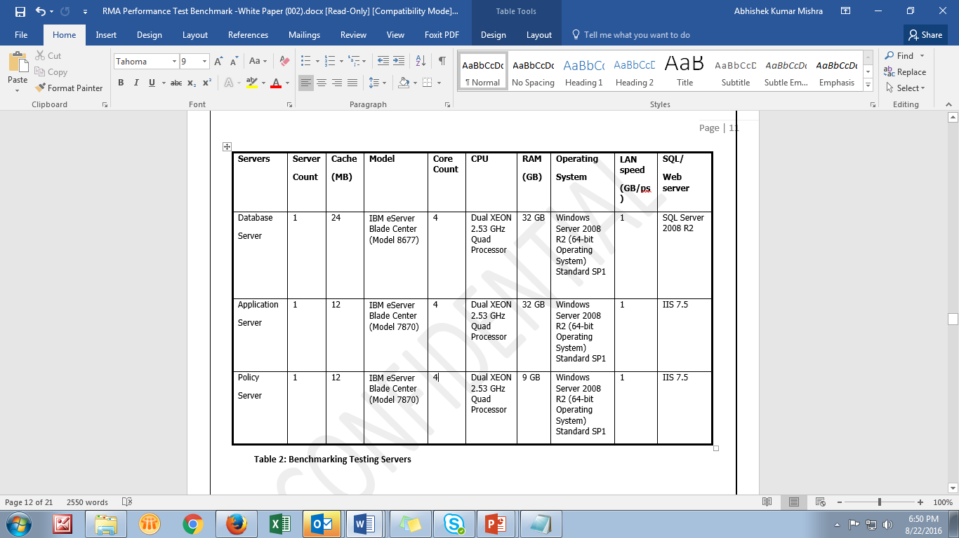

**Table 2: Benchmarking Testing Servers**

# **TEST SCENARIOS**

Benchmark testing used 28 automated test scenarios that represent more than 90 percent of the transaction types which are performed daily at a typical insurance firm, including inquiries, modifications and additions.

* Each test scenario takes three to fifteen user steps, with a “think time” of 10 seconds between steps. Completion times varied among test scenarios.
* The 28 tests scenarios are listed in table below:

**TEST SCENARIOS TABLE**

|  |  |
| --- | --- |
| **Test number** | **Test scenarios** |
| Test 1 | Search GC Claim |
| Test 2 | Search WC Claim |
| Test 3 | Display Claim Record |
| Test 4 | Policy Search |
| Test 5 | Policy Download |
| Test 6 | Save Claim with recently Downloaded Policy Data |
| Test 7 | Display Reserve |
| Test 8 | Add Reserve (Carrier) |
| Test 9 | Save Reserve (Carrier) |
| Test 10 | Save Payment (Carrier) |
| Test 11 | Save Reserve (Corporate) |
| Test 12 | Save Payment (Corporate) |
| Test 13 | Save Collection |
| Test 14 | Save Entity |
| Test 15 | Save Event |
| Test 16 | Display Recent Event |
| Test 17 | Display Litigation Screen |
| Test 18 | Save Litigation Record |
| Test 19 | Edit Litigation |
| Test 20 | Display Diary |
| Test 21 | Create a Diary |
| Test 22 | Create Enhanced Note |
| Test 23 | Display Employee record |
| Test 24 | Display Claim Search screen |
| Test 25 | Search using Claimant Last name |
| Test 26 | Display Attachment |
| Test 27 | Save Attachment |
| Test 28 | Search Diary |

**Table 3: Test Scenarios Table (For Load Test)**

**As an example,** **below table 4 lists the steps in three typical test scenarios:** Save Payment- Carrier Claim (Test 10), Update Litigation Record (Test 19), and Create Enhanced Notes (Test 22).

These test steps excludes- Login, Logout, vuser_init_Transaction, vuser_end_Transaction & Action_Transaction steps for every test case.

|  |  |  |
| --- | --- | --- |
| **Save a GC claim with Policy Data & Save Payment** | **Update Litigation Record** | **Create Enhanced Notes** |
| 1. Create Claim | 1. Search GC Claim | 1. Search WC Claim |
| 2. Policy Search | 2. Display Claim Record | 2. Display Claim Record |
| 3. Policy download | 3. Display Litigation Screen | 3. Create Enhanced Note |
| 4. Save GC Claim | 4. Save Litigation |  |
| 5. Display Reserve | 5. Close Litigation screen |  |
| 6. Create Reserve | 6. Open Litigation Screen |  |
| 7. Save Payment/Collection | 7. Edit Litigation Screen |  |
|  | 8. Close All |  |

**Table 4: Example of Typical Test Scenario steps**

# **BENCH MARK TESTING RESULTS**

**Following sections provide detailed results of the benchmark tests**

**Single Application Server- Mixed User tests**

* The PLAB team is asked to perform a series of single application server benchmarking tests with **an objective to identify the optimal number of virtual users that can be served by a single entry-level application server.**
* These tests were performed on one application server (IBM e-Server Blade Center (Model 7870) with 4 cores and 32 GB RAM) and one database server (Dual XEON 2.53 GHz Quad processors), using the IBM e-Server Blade Center (Model 8677) server to generate the test workload.
* For these single application server tests, the team added virtual users up to a maximum of 100 virtual users. The team ran each scenario 3 times and calculated an average of these test runs.

The test results showed that **the best balance between number of virtual users (in terms of business transactions throughput) and execution time was achieved at approximately 50 virtual users** **with Single application server.**

Test Results were obtained by executing each test script with varied users load from 1 Virtual user to 100 Virtual Users.

**5 runs were executed for each VU. First & fifth runs were discarded and Average of 3 runs was taken to calculate & capture Avg Response time for a transaction.**

**Table 5 - Below is the list of average response times to complete each test scenario by various virtual users on a single server.**

Below test scenarios were identified including both Carrier vs Corporate scenarios based upon customers’ needs.

**Results of single application server tests with various numbers of virtual users-**

|  |  |  |  |  |  |  |  |
| --- | --- | --- | --- | --- | --- | --- | --- |
| **Test scenarios** | **Average Response time (seconds)** | | | | | | |
| **1 virtual user** | **5 virtual users** | | **10 virtual users** | **20 virtual users** | **50 virtual users** | **100 virtual users** |
| Search GC Claim | 1.95 | 2.398 | 2.669 | | 4.671 | 5.363 | 23.756 |
| Search WC Claim | 1.267 | 2.048 | 2.417 | | 5.938 | 20.05 | 34.429 |
| Display Claim Record | 2.224 | 2.154 | 3.167 | | 8.7 | 7.842 | 63.458 |
| Policy Search | 0.642 | 0.536 | 0.928 | | 0.882 | 2.661 | 3.185 |
| Policy Download | 41.323 | 35.379 | 38.669 | | 88.739 | 160.859 | 257.164 |
| Save Claim with recently Downloaded Policy Data | 13.753 | 11.953 | 8.878 | | 13.948 | 72.279 | 36.946 |
| Display Reserve | 0.969 | 1.233 | 1.986 | | 2.735 | 4.86 | 256.16 |
| Add Reserve (Carrier) | 7.334 | 15.652 | 15.368 | | 15.788 | 8.586 | 70.972 |
| Save Reserve (Carrier) | 1.087 | 1.527 | 14.732 | | 27.43 | 5.311 | 2.617 |
| Save Payment (Carrier) | 11.51 | 20.917 | 35.404 | | 32.651 | 19.819 | 37.091 |
| Save Reserve (Corporate) | 2.34 | 1.73 | 2.26 | | 4.139 | 5.906 | 7.185 |
| Save Payment (Corporate) | 2.339 | 1.859 | 2.724 | | 8.58 | 7.81 | 8.164 |
| Save Collection | 11.727 | 15.807 | 16.276 | | 25.902 | 20.718 | 59.489 |
| Save Entity | 1.766 | 0.707 | 0.606 | | 0.684 | 0.682 | 1.323 |
| Save Event | 0.633 | 0.734 | 0.644 | | 0.737 | 1.164 | 1.085 |
| Display Recent Event | 0.065 | 0.111 | 0.068 | | 0.118 | 0.388 | 0.28 |
| Display Litigation Screen | 0.442 | 0.617 | 0.676 | | 0.925 | 4.925 | 9.623 |
| Save Litigation Record | 0.546 | 0.833 | 0.885 | | 1.471 | 2.989 | 5.021 |
| Edit Litigation | 0.858 | 1.324 | 1.252 | | 1.802 | 3.979 | 8.964 |
| Display Diary | 32.073 | 26.705 | 76.235 | | 156.499 | 182.349 | 231.771 |
| Create a Diary | 18.468 | 36.87 | 30.147 | | 165.835 | 182.253 | 155.38 |
| Create Enhanced Note | 3.554 | 5.324 | 11.039 | | 18.385 | 35.741 | 69.685 |
| Display Employee record | 1.597 | 1.331 | 1.491 | | 1.545 | 2.319 | 10.765 |
| Display Claim Search screen | 0.11 | 1.026 | 1.212 | | 1.245 | 3.999 | 21.676 |
| Search using Claimant Last name | 1.428 | 1.624 | 2.882 | | 4.543 | 9.313 | 21.615 |
| Display Attachment | 0.194 | 0.262 | 0.279 | | 0.428 | 1.744 | 4.581 |
| Save Attachment | 0.381 | 0.629 | 0.440 | | 0.345 | 2.43 | 3.421 |
| Search Diary | 1.176 | 2.013 | 1.993 | | 2.631 | 4.689 | 6.444 |
| **Total throughput In General (Business transactions)** | **12** | **60** | **120** | | **240** | **554** | **1182** |
| Average memory utilization | 10.7% | 12.1% | 14.0% | | 15.1% | 18.2% | 18.2% |
| Average CPU utilization | 25.2% | 38.4% | 44.4% | | 59.9% | 75.4% | 75.4% |

**Table 5: Results of single application server tests with various numbers of virtual users**

**Major Observations:**

Policy download related scenarios depends upon external application i.e. POINT and thus the slow performance for all virtual users.

Large VUs set which showed less response time then small VUs set e.g. Add/Save reserve (Carrier claims) are because all users in large VUs set didn’t complete the transaction & failed during the scenario. All such scenarios have been captured and marked as performance improvement areas.

**Throughput –** Indicates the number of transactions per second an application can handle and the amount of transactions produced over time during a test. It varies depending on no. of test steps in a test scenario. Above calculation is taken from a test scenario with 12 steps.

**Memory utilization:** In terms of Load Runner, one should ensure that Memory utilization should always be less than physical memory (RAM) on load generator machines so that minimal paging is required.

**CPU utilization:** In terms of Load Runner one should ensure that CPU usage should always be below (80-85) % on load generator machines for efficient functioning.

***Note- with Multiple Application servers, Throughput increases whereas the percentage of Memory utilization & CPU utilization decreases.***

# **SUMMARY**

**Scalability, stability and performance are important to CSC’s insurance customers.** These customers want assurance of the performance consistency and efficacy of the RMA application in maintaining their growing numbers of claims due to business expansion.

RMA team has worked in a co-ordination with PLAB to ensure that RMA Application is load tested with database characteristics that simulates real world carrier & corporate scenarios. Benchmark testing and product optimizations are part of this joint effort.

RMA Performance tests were designed to simulate the real-world usage pattern of large insurance customers. The test results were impressive. In the single application server test with concurrent users, the measured throughput was above 300 business transactions per minute.

***These results clearly confirm that CSC’s Risk Master Accelerator running on one application (windows) server & dB (SQL server) server can support up to 50 concurrent users.***

The results also show that the system is highly scalable with near-linear scalability. And, it ensures surpass performance as the number of application servers increased with load balancers, by handling the number of concurrent user’s increase.

***CSC customers can select RMA (a risk and claims management software) as a medium to large scale insurance & claim carrier’s solution with confidence.***

# **ADDITIONAL INFORMATION**

CSC is a global leader in providing technology-enabled business solutions and services**. With colossal experience spanning over 50 years, clients from industries and government departments worldwide have shown trust in CSC. They find CSC reliable when it comes to business process & information systems outsourcing, systems integration and consulting needs.**

CSC has about 66,000 professionals who serve clients in more than 60 countries. CSC reported revenue of $8 billion for the 12 months ended March 31, 2016. The company trades on the New York Stock Exchange under the symbol “CSC.”

***For more information about CSC,*** visit www.csc.com.